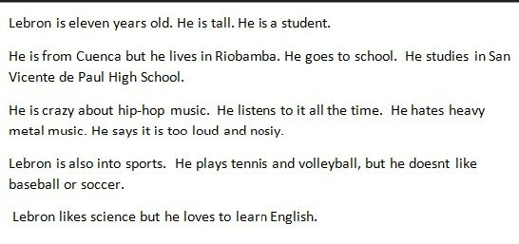
How old is Lebron? Is he tallo r short? What is he?
Where is he from? Where does he go? Where does he study?
What is he crazy about? Why? What type of music does he hate? Why does he hate that type of music?
What is he into? What sports does he play? What sports he doesn’t like?
Does he likes a subject?

