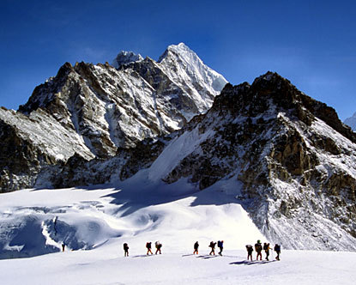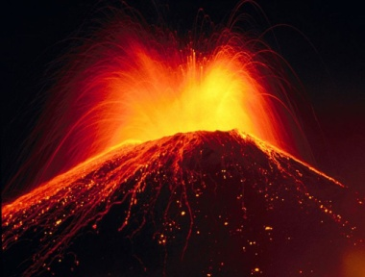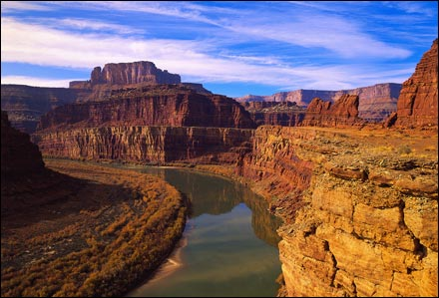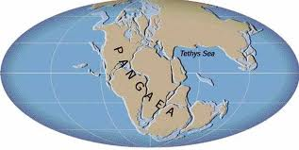

There is a list of terms at the end of this sheet to help you with spelling.

- The North American plate is going to eventually collide with the ____________ plate.
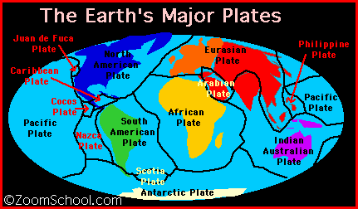
- ____________ ______________ is the mightiest force on Earth.

- What is going to eventually happen to London England? Use the picture below to help.
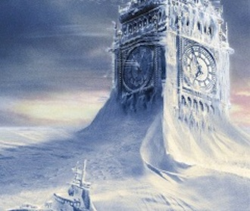
- Briefly explain how the first land masses or continents were formed on Earth back in the beginning when it was nothing but a hot liquid molten rock. Hint: Something about Lead, Nickel...etc
________________________________________________________________________________________________________________________________________________________________________________________________________________________________________________________________________________________________________________________________________________
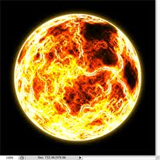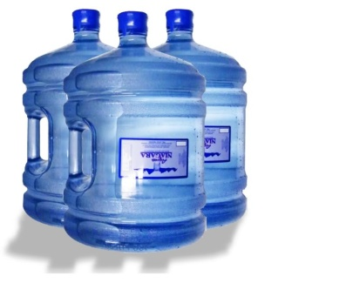
- How do some scientists explain how water came to exist on planet earth?
____________________________________________________________________________________
- What is a ?
____________________________________________________________________________________________________________________________________________________________________________________________________________________________________________________________

- Why is special or relevant to continent building and plate tectonics?
________________________________________________________________________________________________________________________________________________________________________
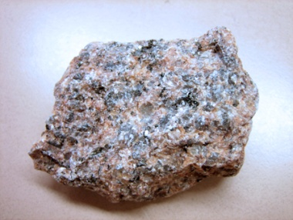
- What do the continental plates sit on or move on? It lay between the crust and the core! _________

- How far do the continental plates move each year? ______________________
- In 1912, a German scientist proposed a radical new theory with regards to the continents. Briefly explain his theory and more importantly explain his justification or evidence.
____________________________________________________________________________________________________________________________________________________________________________________________________________________________________________________________
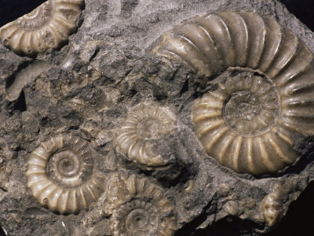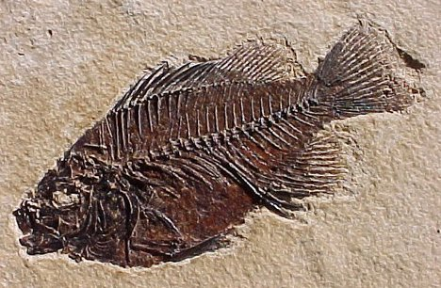

- Plate tectonics is driven by ______________.

- Explain what is happening in ICELAND in relation to plate tectonics.
________________________________________________________________________________________________________________________________________________________________________

- There are over a _______________ continental plates.

- Draw what happens at a subduction zone. Explain what happens to old rock at such a zone with reference to your picture.

- What is the name of the last and most recent supercontinent? _____________

- What is surprising about the top layer of the Grand Canyon?

- List three important things you learned in the last bit of the video clip
- ____________________________________________________________________
- ____________________________________________________________________
- ____________________________________________________________________

List of terms:
- Alfred Wegener
- Eurasian Plate
- Mantle
- Pangea

